**Coding Challenges: CareerHub, The Job Board**

**Main Menu :**

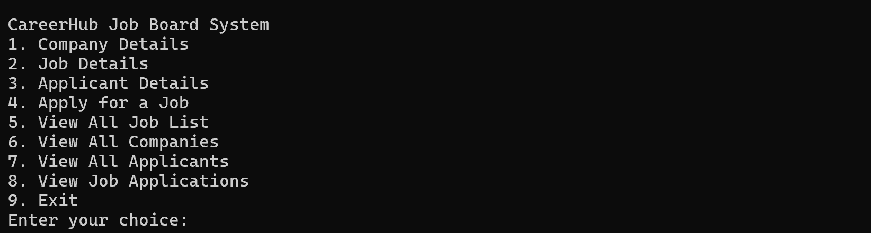

**1 . Company Details :**

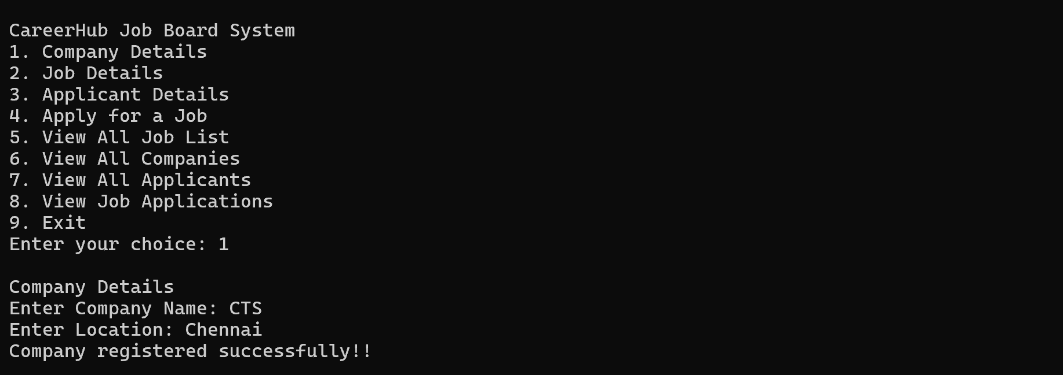

**2 . Job Details :**

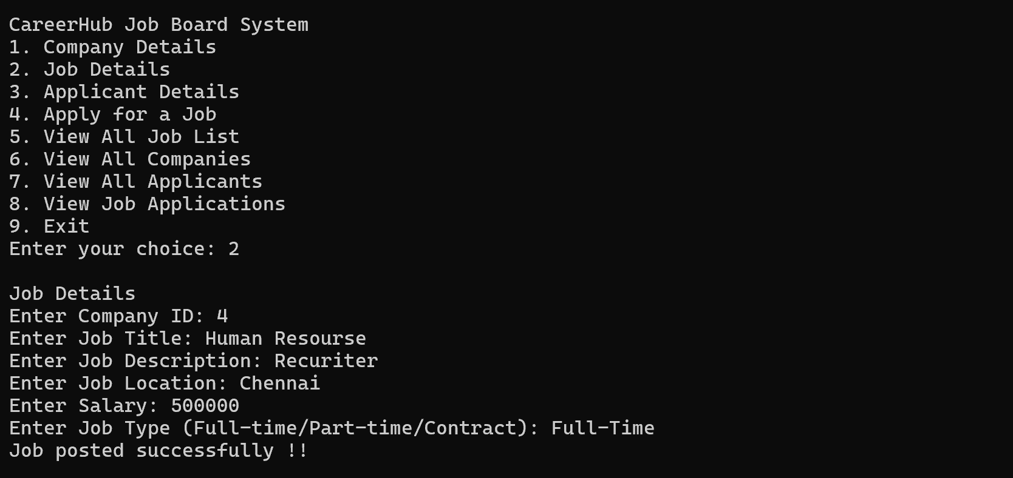

**3. Applicant Details :**

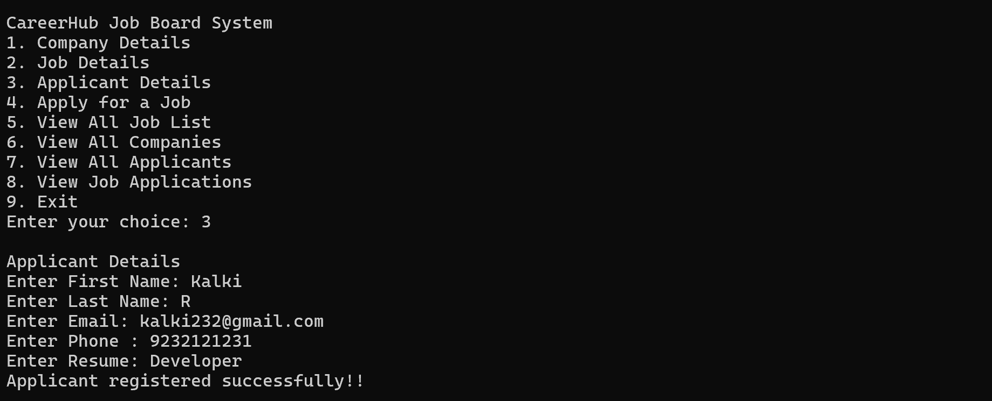

**4.Apply for a Job :**

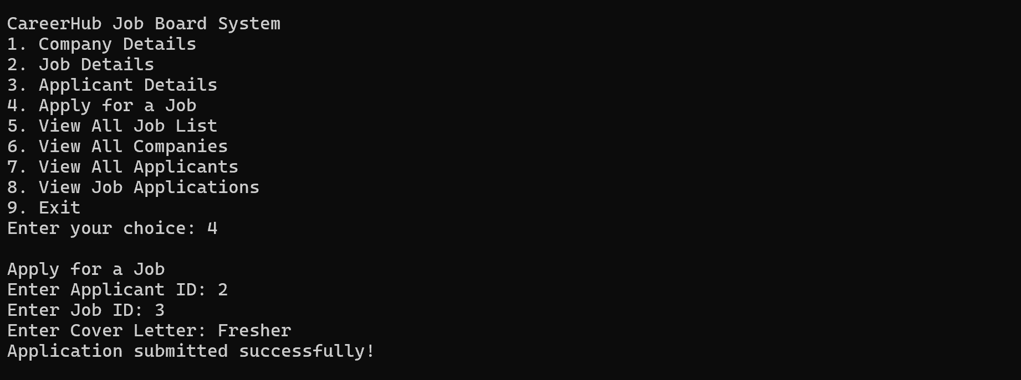

**5. Job Details :**

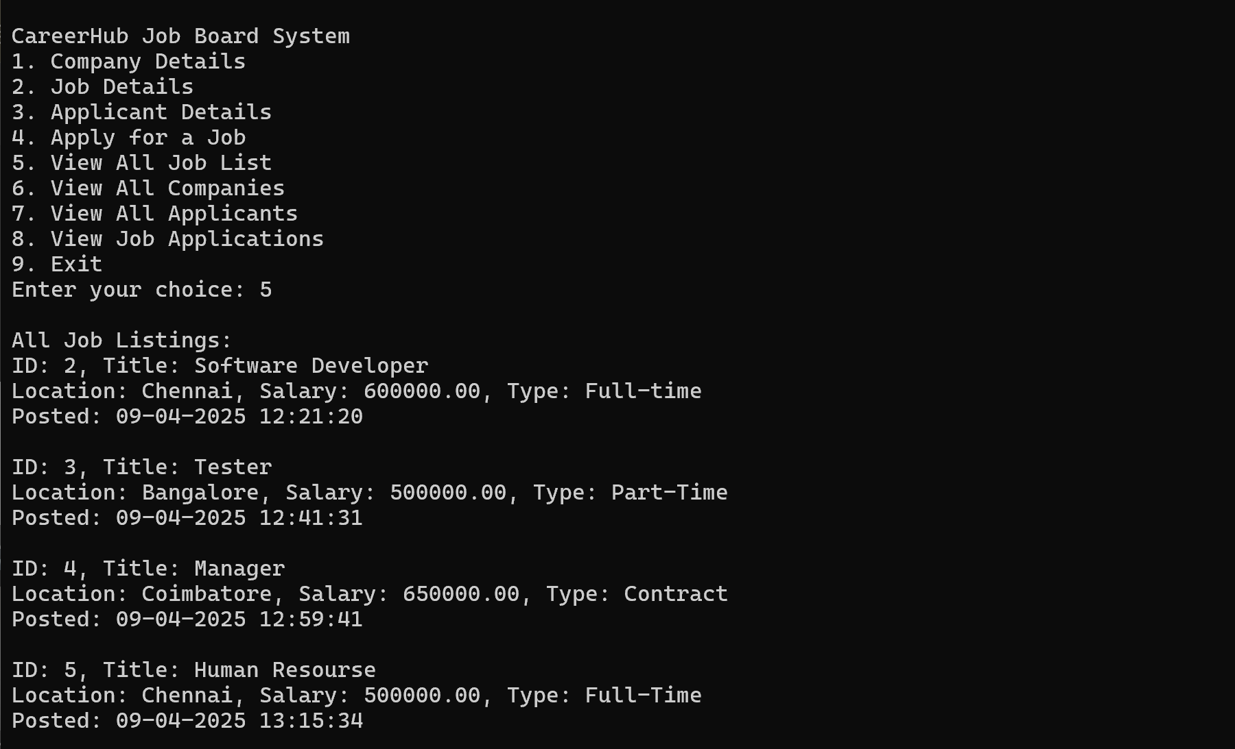

**6. Company Details :**

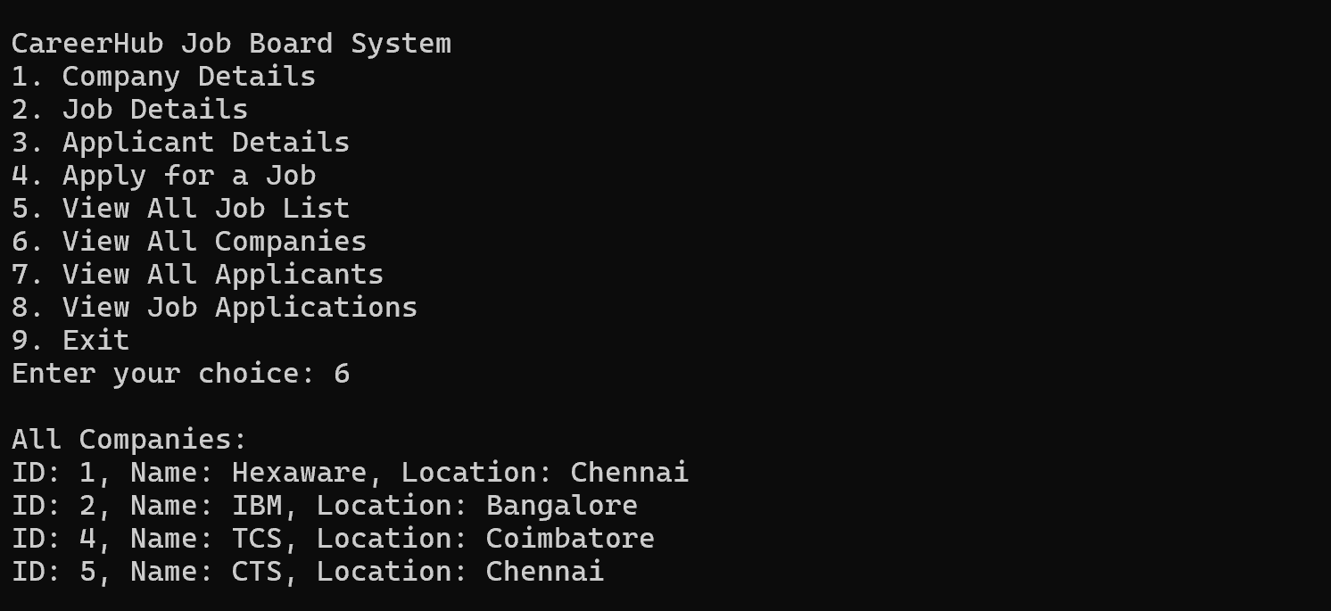

**7. Applicant Details :**

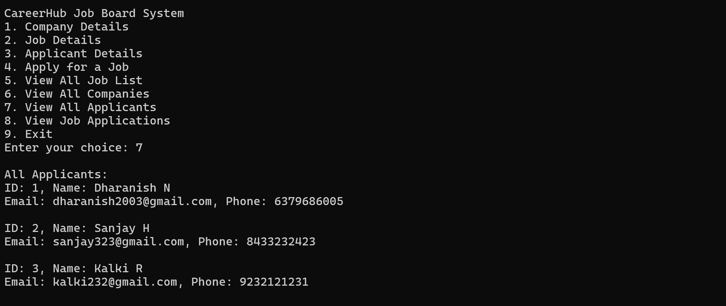

**8 . Application Details :**

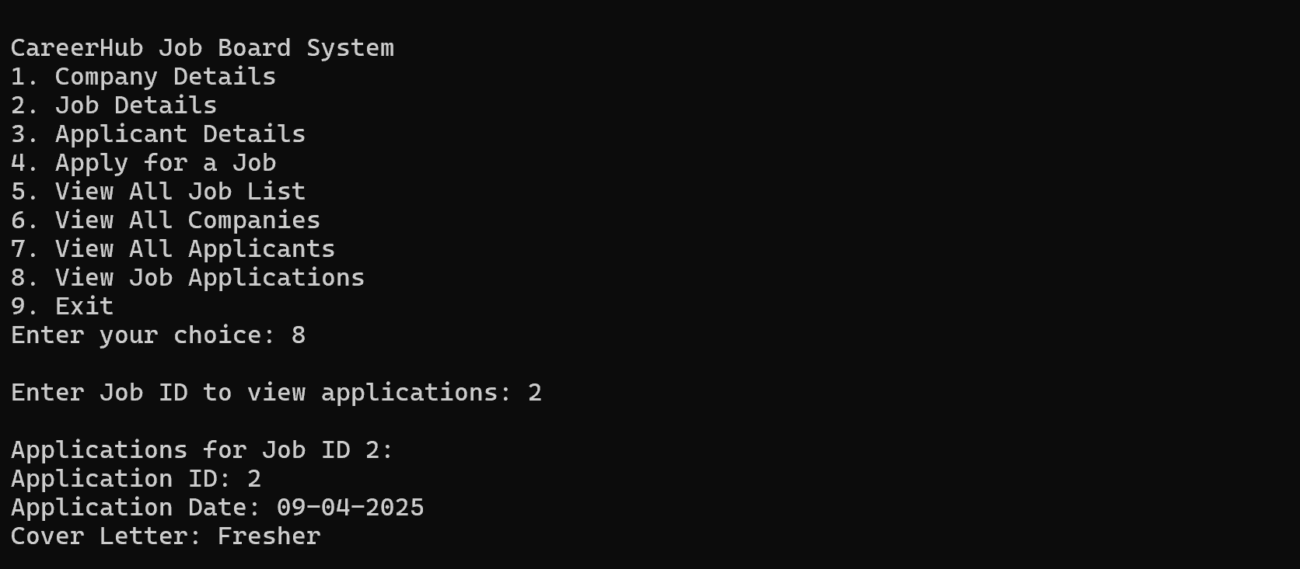

**9. Exit :**

